# Team Projects Brief

## **1. Analytics Team**

*Team members:* Anh Quan Hua (Team Leader)

Anh Linh Le

Bowen Li

Xiaolu Li

Gouri Nandan Reddy Gangavaram

## **2. Past and Current Projects**

*Game Sales Analysis – Completed:*

For our first project, we were tasked with analyzing 3 datasets about video game sales for the year 2016, 2017 and 2019. Our goal was to see if there exists any demand or growth for fitness and health genre as well as present the marketability of this gaming segment. We then proceeded to process, analyze data and visualize our findings using a combination of Python and Tableau. Finally, a report was produced to highlight the key insights and present a well-rounded argument for our analysis.

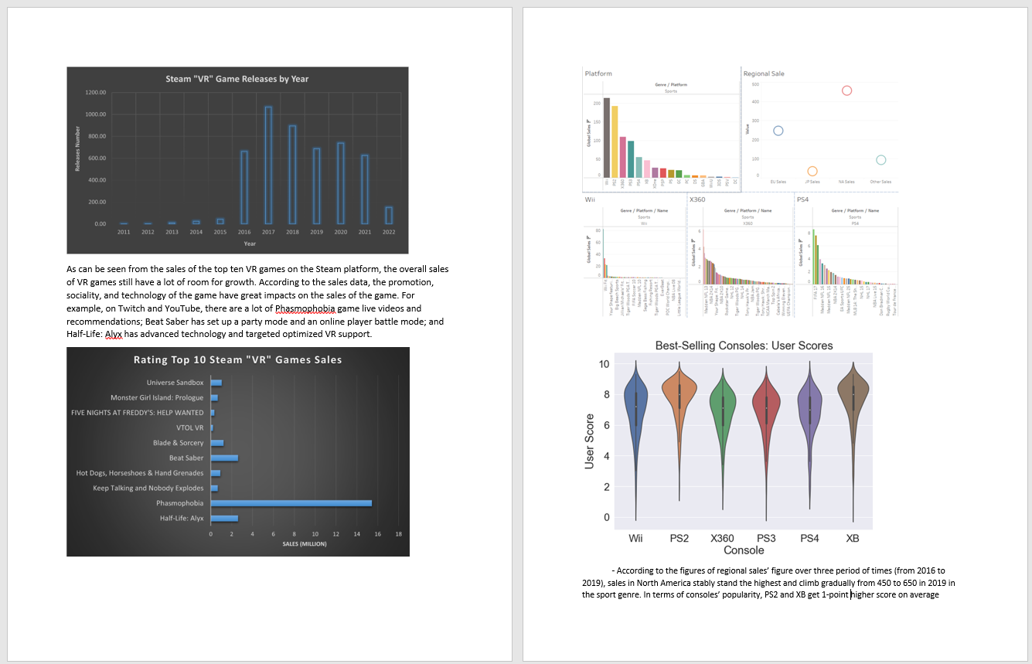

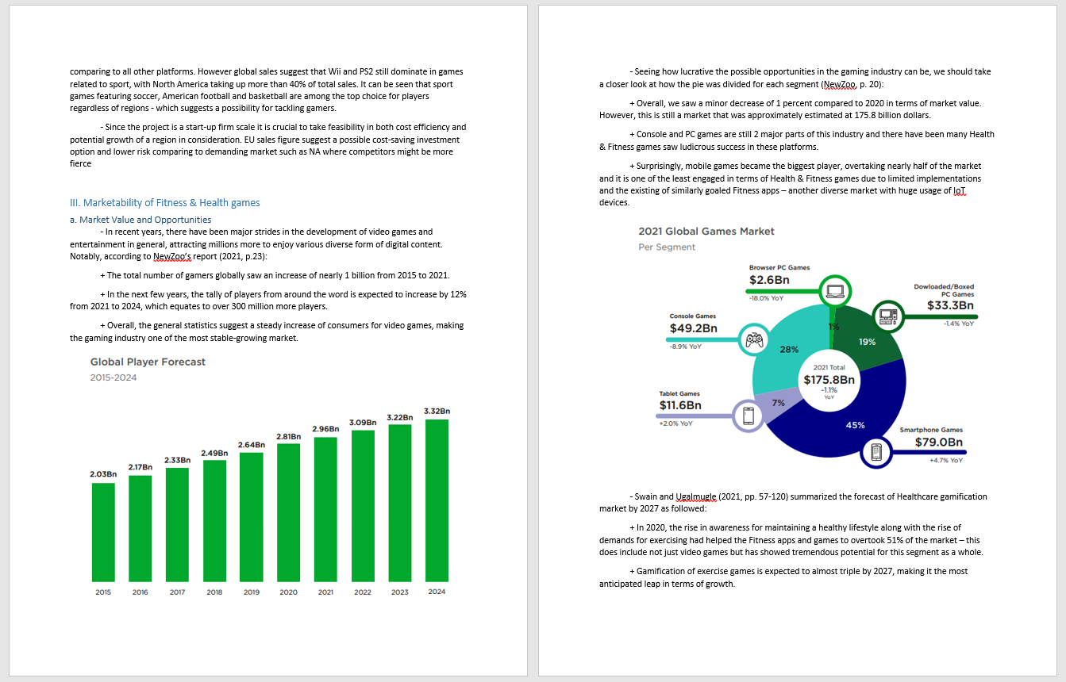 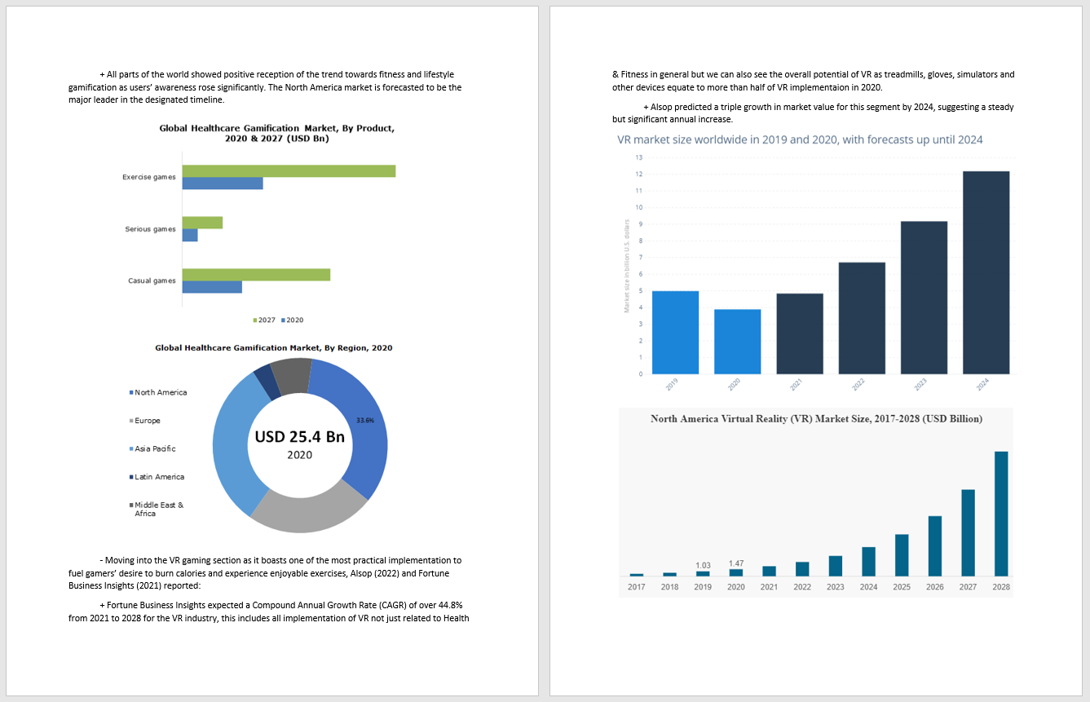

*Fitbit Tracker Analysis – Completed:*

With our second project, we made a suggestion to conduct another analysis on users’ behavior with smart wearables – in this case, our target of choice were Fitbit tracker data. In this project, we individually conduct our analysis on the data then compiled all the notebooks together to work out different insights. A report was also produced to document and summarize our work.

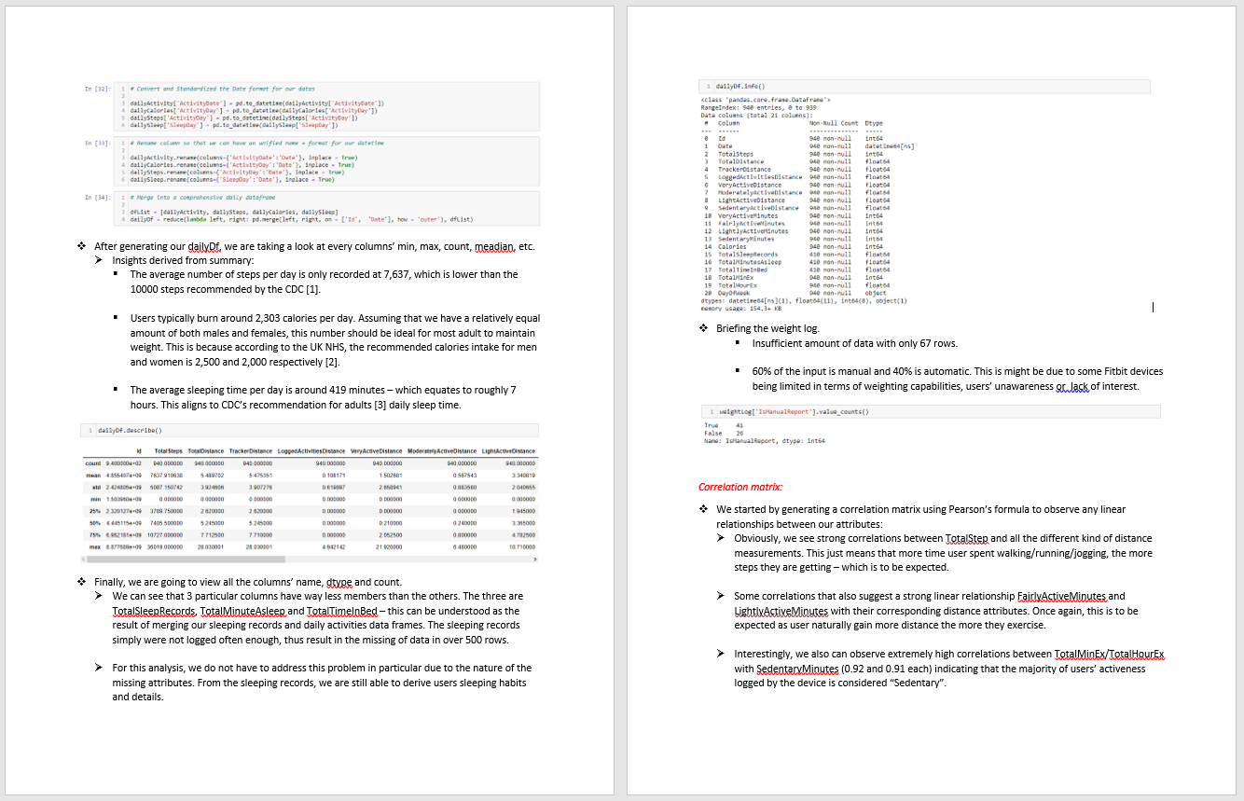

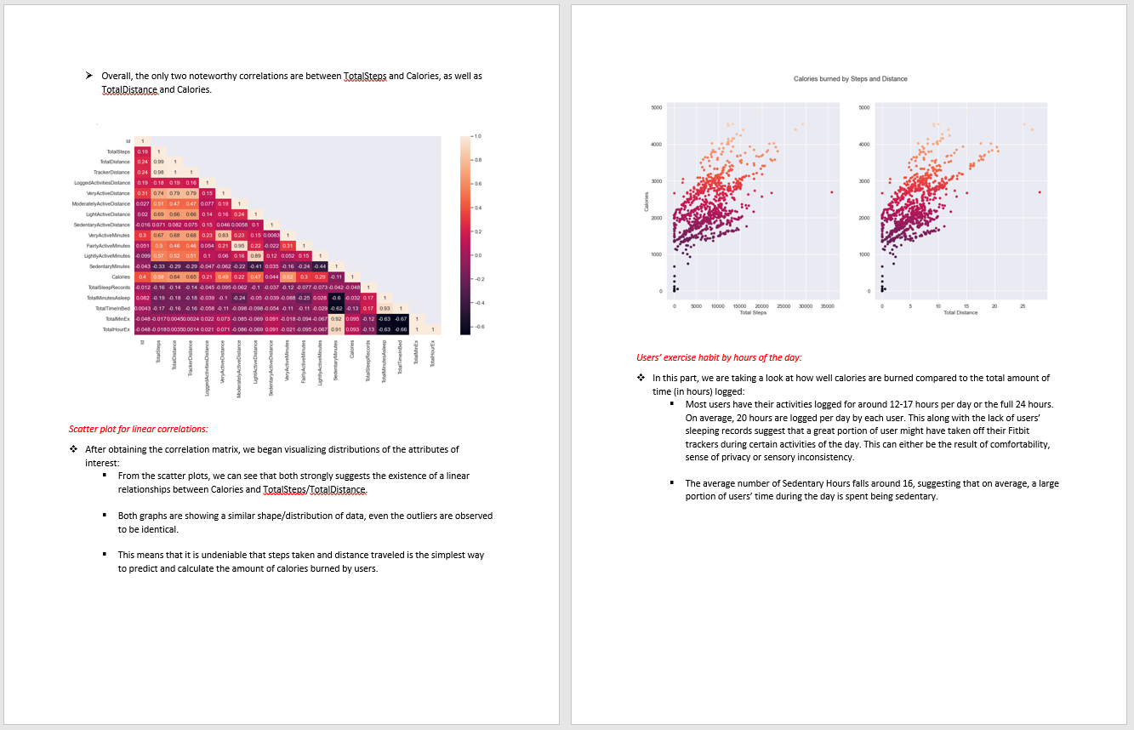

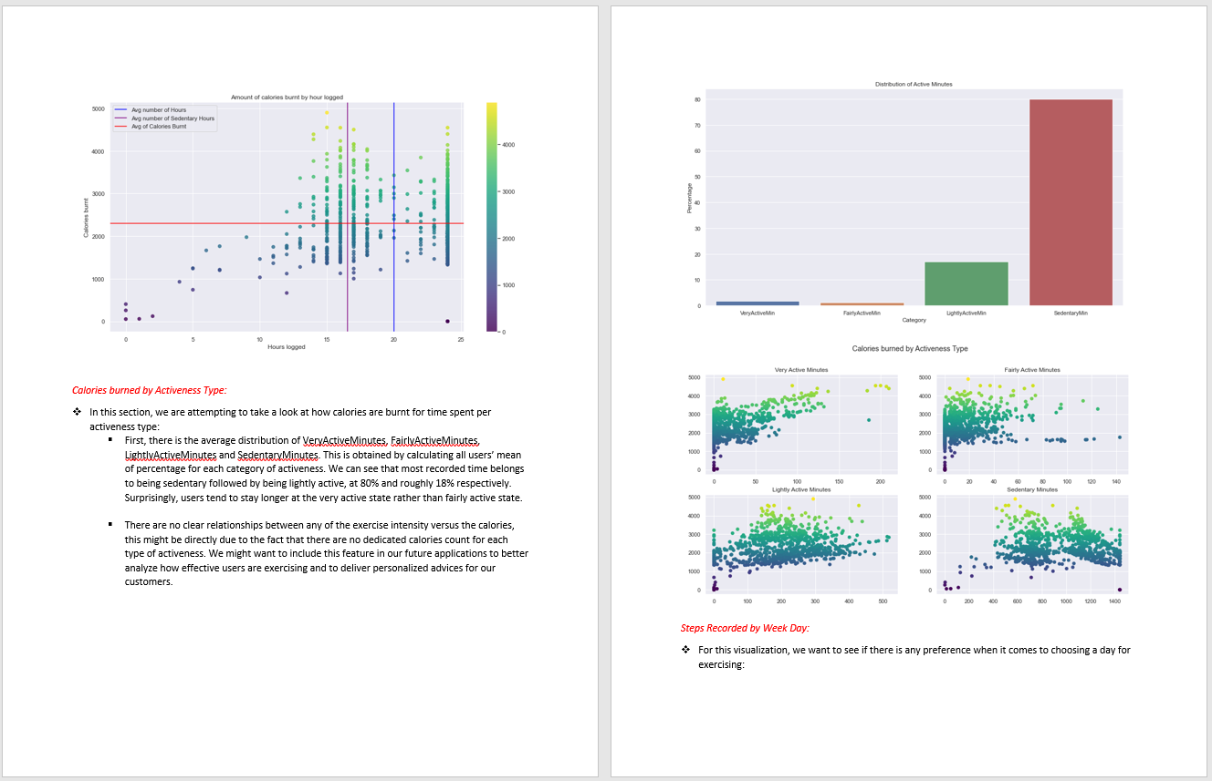

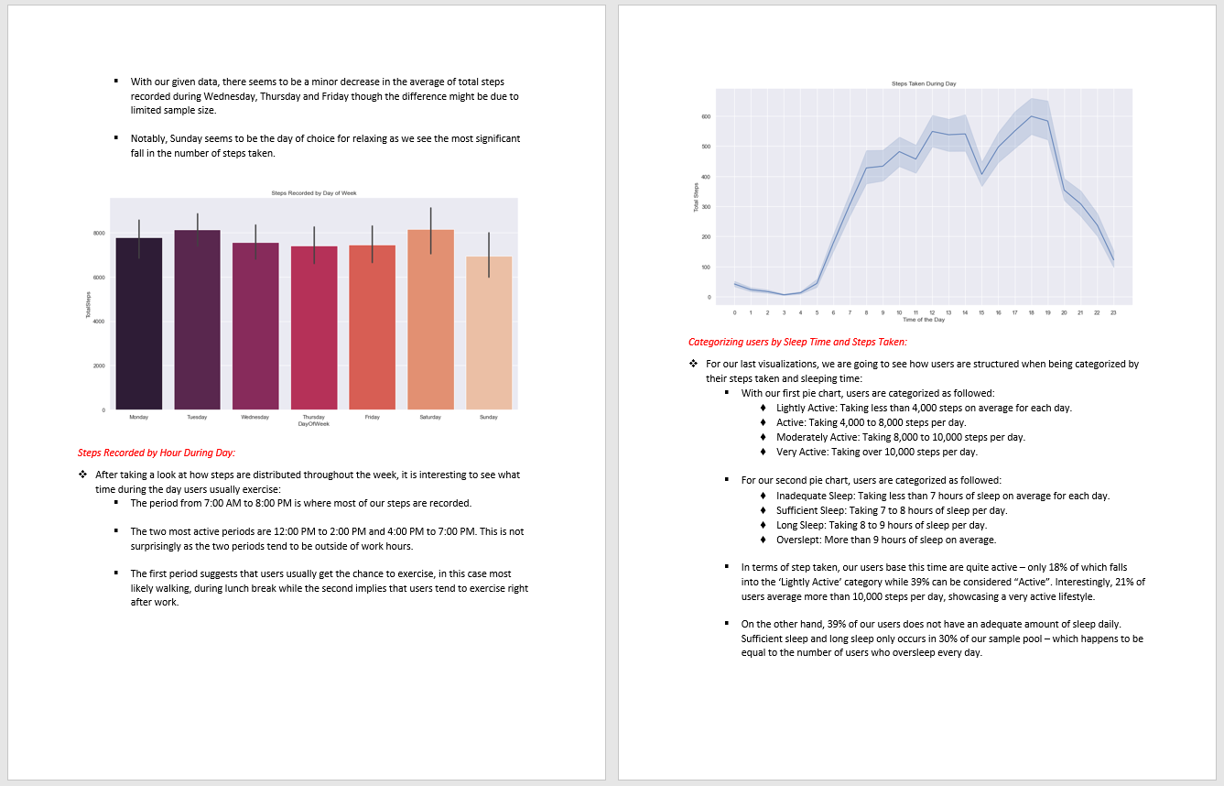

*Tableau Dashboard – Ongoing:*

With our last project for the unit, we decided to develop a Tableau dashboard to showcase our previous projects and possibly be used for future analyses. At the moment, we are working on documenting the process and have produced some iterations/demo for the dashboard.

